WORKOUT PLANNER

. Problem Statement
In today's fast-paced world, maintaining a consistent fitness routine is a significant challenge for many individuals. Beginners often feel overwhelmed by the complexity of creating a workout plan, while intermediate gym-goers struggle to track progress effectively without expensive personal trainers.
Most existing fitness apps are either too generic—providing "cookie-cutter" templates that don't account for available equipment (e.g., Home vs. Gym)—or too complex and expensive for the average user. There is a lack of accessible, user-friendly tools that can instantly generate personalized routines based on specific user constraints like BMI, age, and fitness goals.

2. Proposed Solution
FitTrack is a comprehensive web-based application designed to bridge the gap between expensive personal training and generic fitness advice. It uses a smart algorithm to generate customized workout schedules tailored to the user's specific physical metrics and available equipment.
Key Features of the Solution:
- Smart Onboarding Engine: Users input their age, weight, height, and fitness goals (e.g., Muscle Gain, Weight Loss). The system calculates BMI and suggests an appropriate intensity level.
- Dynamic Plan Generation: The core feature is an algorithm that constructs a daily workout routine. It intelligently selects exercises based on whether the user has selected "Gym" or "Home" equipment.
- Interactive Dashboard: A visual dashboard allows users to view their daily tasks, mark exercises as complete, and track their consistency through a "Day Streak" counter and gamified "Achievements."
- Secure & Private: Built with full authentication (JWT & Google OAuth), ensuring user data and progress history are stored securely.
1. Secure Authentication  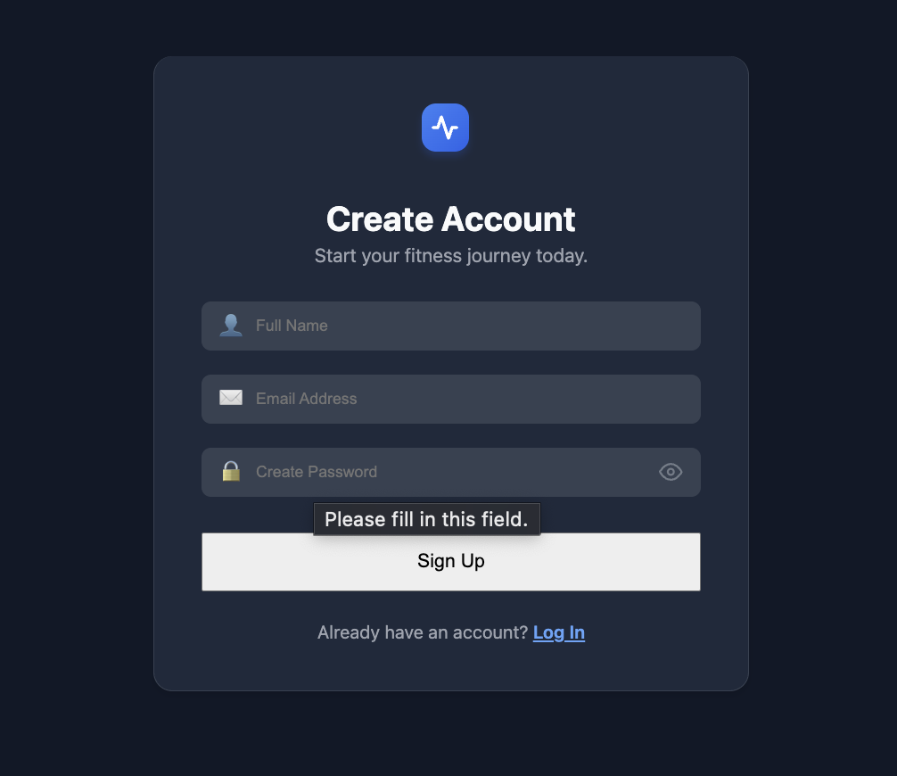 | 2. Personalized Onboarding  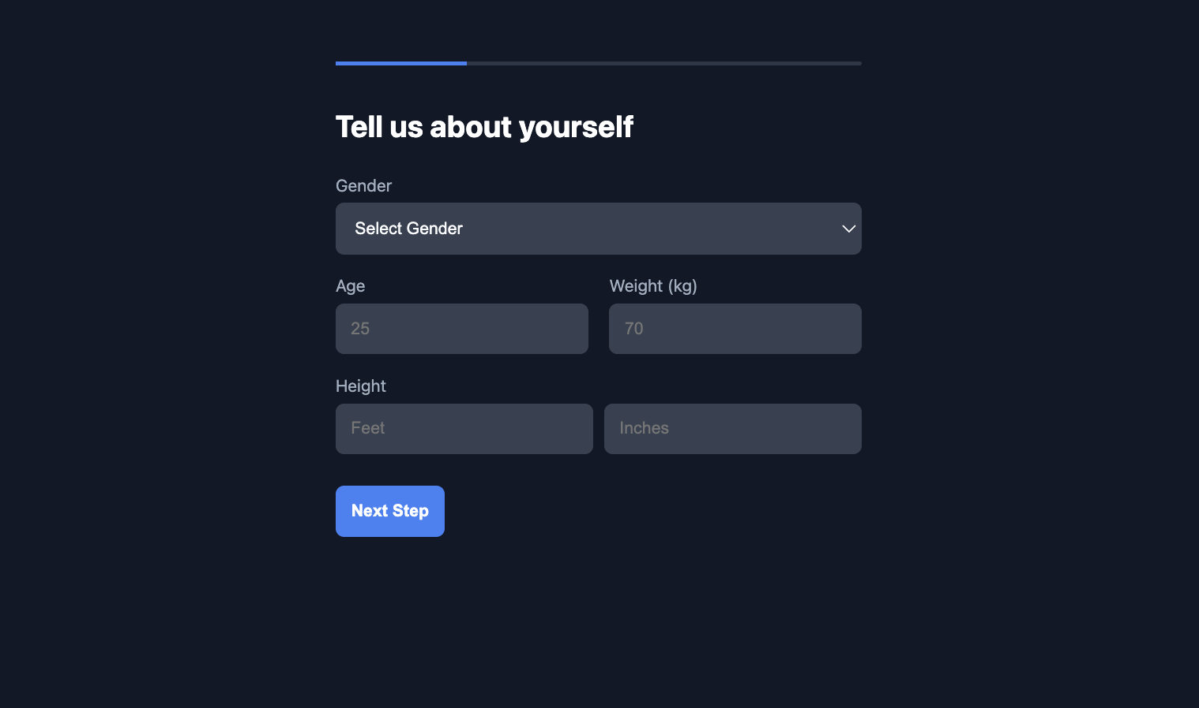
3. Plan Generation & Customization  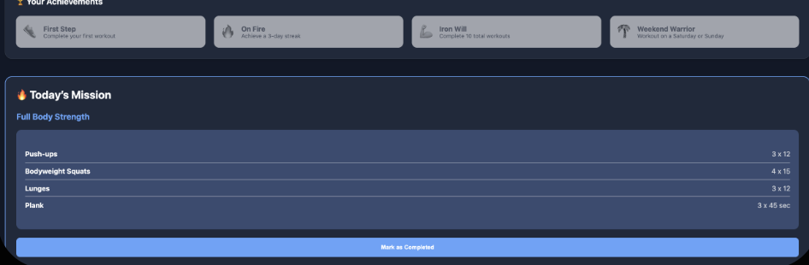 | 4. The User Dashboard  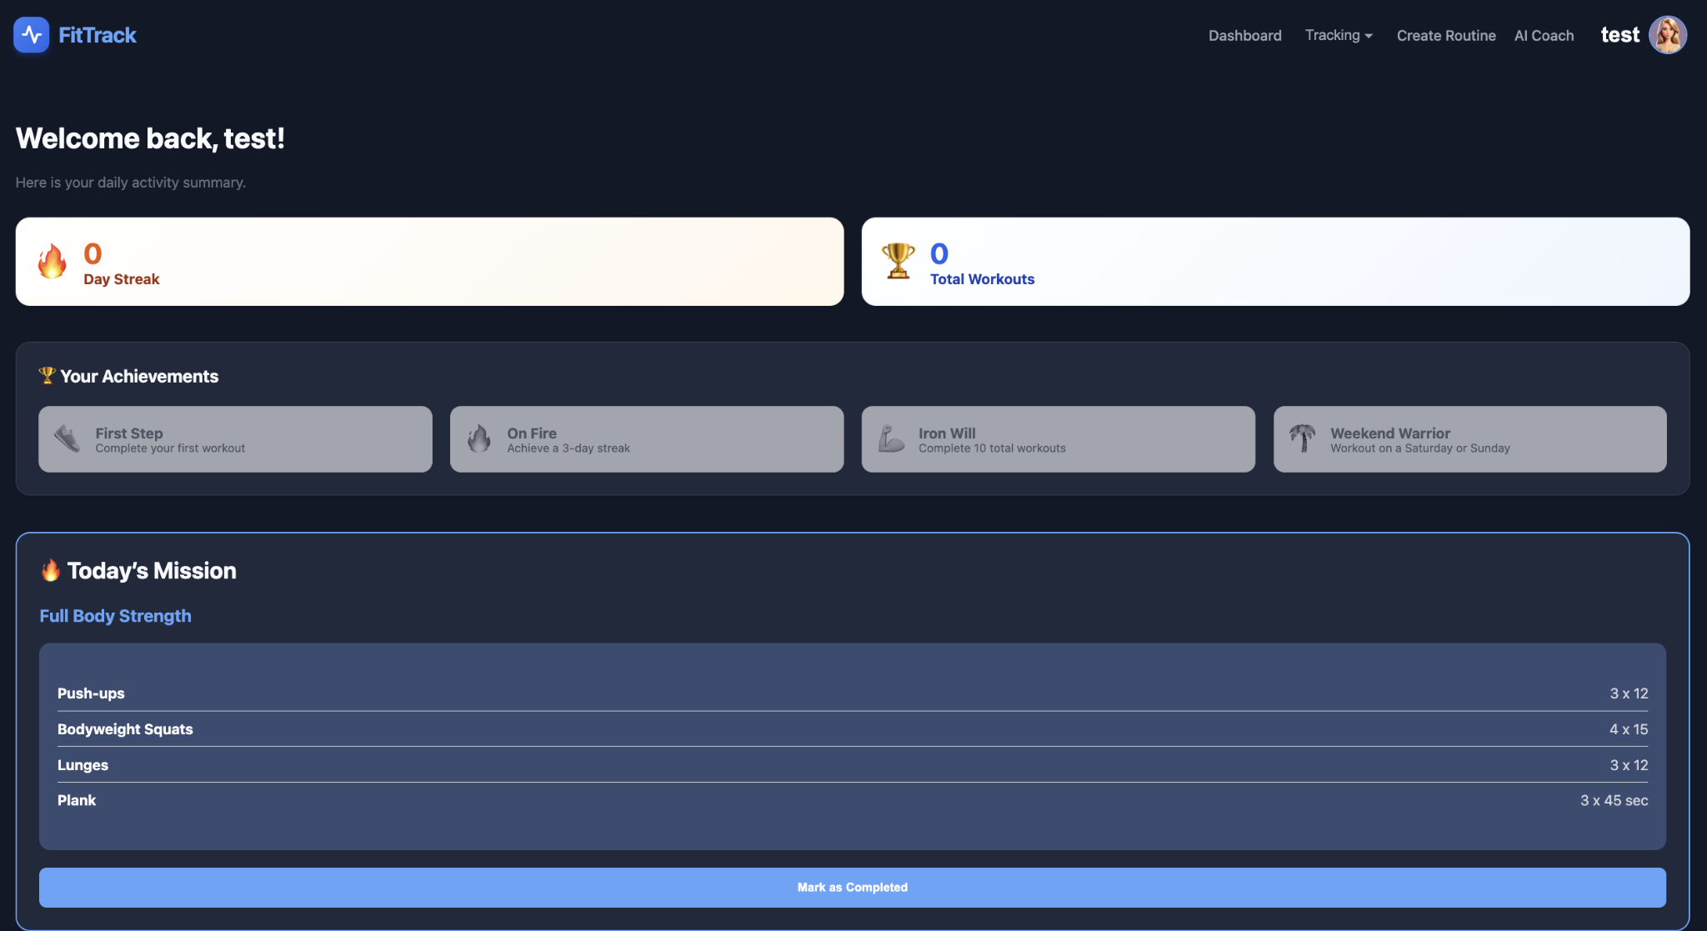
5. Workout Tracking & Schedule  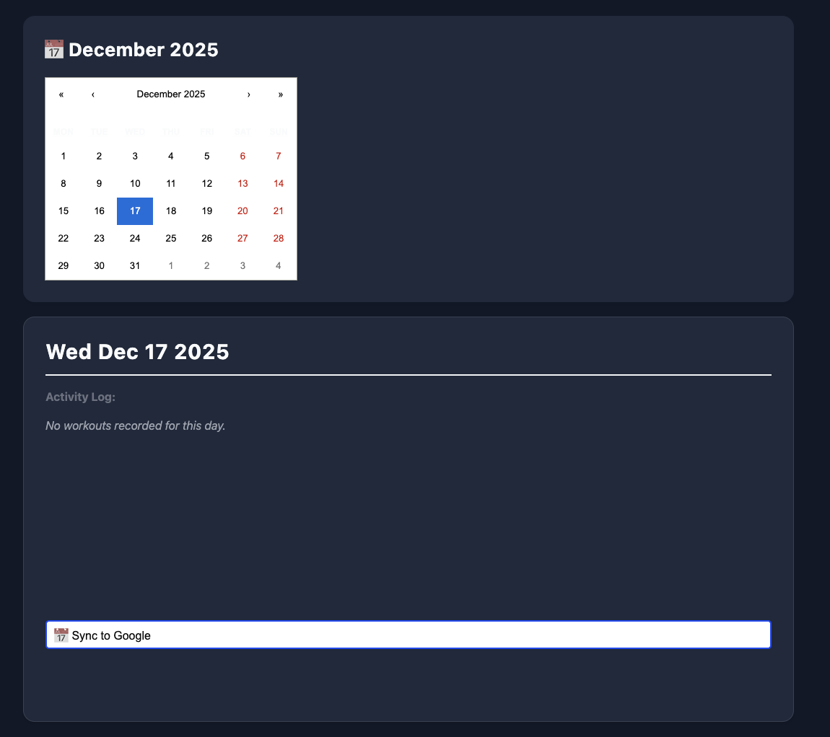 | 6. Nutrition calc  